**Chapter 2**

Endocrine system

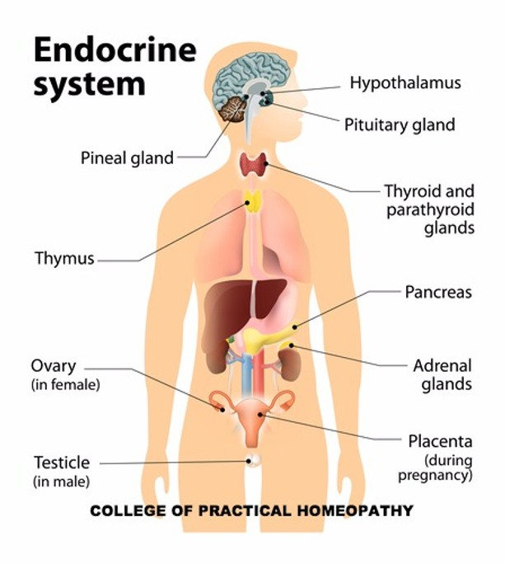

**Homeostasis and disease**

**Endocrine system**

* The endocrine system is made up of glands which make and secrete hormones, and made up of hormones which are chemical messengers

Two kinds of glands in the body:

* Exocrine Glands – secrete into a DUCT 🡪 carries secretion to the surface (sweat glands) or a body cavity (salivary glands)
* Endocrine glands – secrete into EXTRACELLULAR FLUID 🡪 Passes into capillaries and transported by the blood.

SECRETIONS FROM ENDOCRINE GLANDS ARE CALLED HORMONES

**Hormones**

* 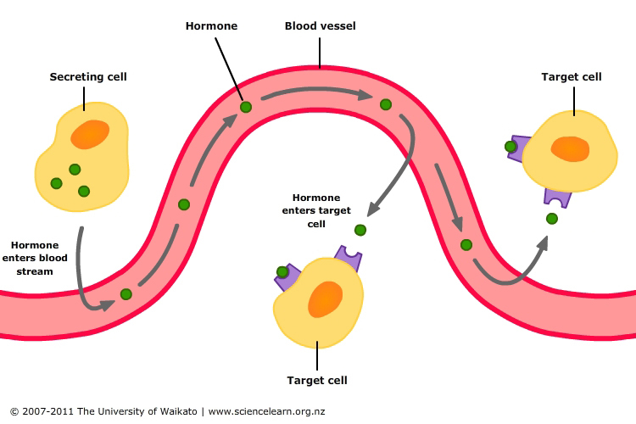Synthesized (made by transcription and translation) and secreted (released – into extracellular fluid 🡪 into blood stream) by specialised cells in glands in response to a STIMULAS (a change in the body)
* Transported by the blood stream (circulatory system) from secreting cells/organs

Cells must have the correct receptor for the hormone; each hormone receptor is specific for a particular hormone (similar to enzymes and substrates)

*Hormones are specific they only bind to one receptor*

*target cells have receptors for specific hormones, outside of cell*

… Side note … **Paracrine (local hormones)**

* How cells in the same tissue communicate with each other
* Can only change the function of the cells in close proximity
* Different from hormones because: - secreted by all cells in the particular tissue (not just specialled cells) – move through extracellular fluid (not blood stream)

**E.G. cells in pancreas communicate to increase amount of insulin released after eating**

**local hormones that are within one tissue not blood stream.**

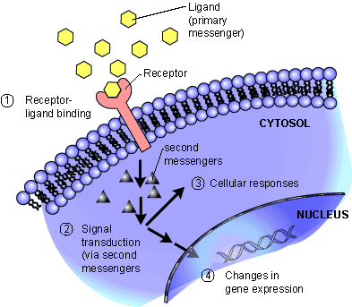**Structural Types of hormones**

* Structure of a hormone changes what happens when the hormone arrives at the target cell.
* PROTEIN AND AMINE
  + WATER SOLUBLE 🡪 CANT PASS THROUGH THE CELL MEMBRANE
* STERIOD
  + LIPID SOLUBLE 🡪 CAN PASS THROUGH THE CELL MEMBRANE

**PROTEIN AND AMINE HORMONES**

**STERIOD HORMONES**

**What do hormones do?**

* Change the function of cells by changing the type, activities or quantities of proteins produced
  + Activate certain genes in the nucleus so that a particular enzyme or structural protein is produced
  + Change the shape or structure of an enzyme so it is then turned ‘on’ or ‘off’
  + Change the rate of production of an enzyme or structural protein by changing the rate of transcription and translation during protein production

**\*\*REMEMBER\*\***

* PRODUCTION of enzymes and structural proteins 🡪 activate gene 🡪 influence rate of transcription/translation
* FUNCTION of enzymes 🡪 change the shape 🡪 turn on/off

**Enzyme Amplification**

* Enzymes are essential for life (catalysts for metabolic chemical reactions)
* Need for large amounts to be produced
* If only one enzyme molecule was produced for every hormone molecule there wouldn’t be enough enzyme to maintain life (saturation of hormone receptors)
* Instead… hormone bines to a receptor 🡪 triggers production of lots of enzymes
* So ... small amount of hormone = big effect
* Cascade effect 🡪 number of reacting molecules involved is increased hundreds or thousands of times along the metabolic pathway

**Control of hormones**

* Hormone production must be very closely regulated (small amount = big effect)
* Over secretion or undersection will result in the body not functioning correctly
* Generally regulated by a negative feedback system
  + Response produced by hormone secretion is the opposite of the stimulus that caused the secretion
    - Example: high level of glucose (stimulus) 🡪 release insulin 🡪 glucose level drops (response) 🡪 stop releasing insulin
* ‘turning off’ a hormone can be done by breaking it down, usual in the liver, kidneys or occasionally the target organ.

**Endocrine glands**

|  |  |  |  |  |
| --- | --- | --- | --- | --- |
| **Gland** | **Location** | **Hormone** | **Stimulus** | **Response** |
| Pineal | Deep in brain | Melatonin | By darkness  Inhibited by light | Regular sleep patterns  Sleep/awake |
| Thyroid | below the larynx – | Thyroxine | TSH (release from anterior lobe of pituitary gland) | Increases metabolic rate, therefor oxygen consumption and heat |
| Parathyroid | Rear surface of thyroid gland | Parathyroid hormone (PTH) | Low levels of calcium in blood | Increases level of calcium  Reabsorption of calcium |
| Thymus | Chest | Thymosin (group of hormones) | Immature t-lymphocytes (type of white blood cells needed for immune response) | Stimulates development and maturation on T lymphocytes |
| Adrenal Cortex | Kidney | Aldosterone  Cortisol | Stressful situation | Reduces the amount of sodium and increases the amount on potassium in urine  Promotes normal metabolism. Helps the body deal with stress and promotes the repair of damaged tissues |
| Adrenal Medulla | Kidney | Adrenaline + Noradrenaline | Fight or flight (stressful situation) | Prepares the body for flight-or-fight responses. Increase in rate and force of heartbeat. |
| Pancreas | Just below stomach, next to duodenum | Insulin  Glucagon | blood glucose | Stimulates the uptake of glucose. Lowers blood glucose levels  Stimulates the breakdown of glycogen and fat to increase blood glucose levels |
| Gonads: Testes |  | Androgens |  | Stimulates sperm production. Growth of skeleton and muscles and secondary sexual characterises |
| Gonads: Ovaries |  | Oestrogen  Progesterone |  | stimulates the development of female characteristics and regulates the menstrual cycle  Regulates menstrual cycle, pregnancy, and prepares mammary glands for milk secretion |

**HYPOTHALAMUS**

* Found at the base of the brain
* Monitors homeostasis and regulates many basic body function
  + Body temp
  + Water balance
  + Heart rate
* Monitors levels of hormones and other chemicals in the blood passing through it
* Detects changes through the nervous system and blood
* FUNCTIONS ARE CARRIED OUT BY THE PITUITARY GLAND
* Hypothalamus secretes
  + Releasing factors 🡪 stimulus release of hormones
  + Inhibiting factors 🡪slows down secretion of hormones

**Pituitary gland**

* Found under the hypothalamus 🡪 joined by the infundibulum
* Has two lobes which function separately:
  + ANTERIOR (front) LOBE 🡪 connected to hypothalamus by network of blood vessels
  + POSTERIOR (back) LOBE 🡪 connected to hypothalamus by nerve fibres
* These two lobes respond differently and are under the control of the hypothalamus in different ways
* Pituitary hormones regulate activity of other endocrine glands (control other glands)

|  |  |
| --- | --- |
| Hypothalamus | |
| Inhibitory or releasing factors from hypothalamus | Hormones made in hypothalamus passed on |

|  |  |
| --- | --- |
| Anterior lobe of pituitary gland | Posterior lobe of the pituitary gland |
| Produces its own hormones | Hormones produced in hypothalamus |
| Connected via blood vessels | Release stimulated by nervous conduction |
| Releases numerous hormones | Oxytocin an ADH |

**ANTERIOR LOBE (MAKES RELEASING FACTOR)**

* Releases several hormones as a result of stimulation via tiny blood vessels of releasing factors from hypothalamus
* All hormones released form anterior lobe stimulate the activity of a specific target organ, except for growth hormone
* Hormones produced by the hypothalamus travel through the blood to stimulate and inhibit the release of hormones made in the anterior lobe

**POSTERIOR LOBE (RELEASES HORMONES)**

* DOES NOT MANUFACTOR HORMONES, it only releases
  + Special nerve cells in hypothalamus produce two hormones 🡪 these nerve cells have long extensions that pass through the infundibulum to the posterior lobe 🡪 release of these hormones triggered by nerve impulses initiated by hypothalamus
* Posterior lobe releases hormones into the blood stream

|  |  |  |
| --- | --- | --- |
| **Hormone** | **Target Organs** | **Main Effects** |
| **Anterior lobe of pituitary** | | |
| Follicle stimulating hormone (FSH) | Ovaries (female)  Testes (male) | Follicle production (growth/development)  Production / maturation of sperm |
| Luteinising Hormone (LH) | Ovaries  Testes | Ovulation + maintenance of corpus luteum  Secretion of testosterone |
| Growth Hormone (GH) | All cells | Growth of skeleton and muscles  Controls protein synthesis and general body metabolism |
| Thyroid stimulating hormone (TSH) | Thyroid gland | Stimulates hormone production on the thyroid |
| Adrenocorticotrophic hormone (ACTH) | Adrenal cortex | Stimulates release and production of hormone in adrenal cortex |
| Prolactin (PRL) | Mammary glands | Initiates and maintains milk secretion in females |

|  |  |  |
| --- | --- | --- |
| **Hormone** | **Target Organ** | **Main Effects** |
| **Posterior Lobe** | | |
| Antidiuretic Hormone (ADH) | Kidneys | Causes increased reabsorption of water from the kidneys |
| Oxytocin (OT) | Uterus  Mammary Gland | Stimulates contraction of the muscles of the uterus  Stimulates contraction of cell in the mammary glands causing the release of milk |

**Thyroid disorders**

Hypothalamus produces TSH releasing factor 🡪 anterior lobe of pituitary gland 🡪 TSH 🡪 thyroid gland 🡪 production of T3 and T4

* T3 🡪 triiodothyronine 🡪 3 iodine molecules (less important hormone)
* T4 🡪 thyroxine 🡪 4 iodine molecules (more important hormone)
* Regulates basal metabolic rate 🡪 metabolism of carbohydrates, protein and fat
* Reactions generate heat
* Hyperthyroidism 🡪 TOO MUCH thyroxine
* Hypothyroidism 🡪 TOO LITTLE thyroxine

**HYPERTHYROIDISM – TOO MUCH THYROXINE**

* Most common form 🡪 Graves Disease
* CAUSE: enlarged thyroid due to immune system reaction
  + Body produces antibodies that attach to TSH receptors 🡪 makes the thyroid continuously produce thyroxine
* EFFECT: overstimulated cells (due to antibodies. Binding to receptors) produce excess thyroxine
* **SYMPTOMS: rapid heartbeat, weight loss, increased appetite, fatigue, sweating, anxiety, protruding eyeballs**
* **TREATMENT: DRUGS TO block thyroids use of iodine (cant make thyroxine If iodine is not available)** 
  + **Surgery to remove part of the thyroid gland**
  + **Drinking radioactive iodine which targets thyroid cells, which are killed by the radioactivity**

**HYPOTHYROIDISM – TOO LITTLE THYROXINE**

* CAUSE: 1. Iodine deficiency 2. Own immune system attacks thyroid (Hashimoto’s) 3. Removal of part or all of the thyroid (usually due to cancer)
* EFFECT: 1. Insufficient iodine available for synthesis T3 and T4 2. Damaged thyroid cells are unable to produce adequate amounts of thyroxine 3. Thyroid cells removed 🡪 reduces amount of thyroxine produced
* TREATMENT: 1. Inclusion of extra iodine in diet (iodised salt, bread) 2 and 3. Synthetic thyroxine (levothyroxine)]
* SYMPTOMS: slow heart rate, unexplained weight gain, fatigue, intolerance to cold, swelling to the face, goitre.

**Treatment: synthetic hormones**

* Thyroxine is essential for life
* Hormones made in a laboratory (not extracted from another human or animal)
* Not identical to human hormones 🡪 can have slight molecular differences 🡪 can result in slightly different responses in the body
* Must have correct dosage 🡪 too little or too much can cause side effects

**Human growth hormone deficiency**

* Growth hormone is essential for normal growth
* Deficiency 🡪 growth retardation or dwarfism
* Can be treated with injections of growth hormone
* Made using recombinant DNA technology involves introducing DNA into a cell from a different type of organism
* In this case: Human DNA is inserted into bacteria

**Steps in recombinant DNA process**

1. Isolated gene in question 🡪 from human cell
2. Restriction enzyme cuts DNA with gene for desired protein

🡪 straight cut with blunt ends

🡪 staggered cut with sticky ends

1. Plasmid extraction from bacteria
2. Same restriction enzyme (that was used on human DNA) cuts the plasmid 🡪 gene is inserted into the plasmid (splicing) 🡪 DNA ligase ‘glues’ inserted gene in plasmid
3. Recombinant plasmid is cloned to form several copies
4. Bacterial cell is treated so it ‘takes up’ the recombinant plasmid
5. Bacteria will produce the desired protein 🡪 harvested for use

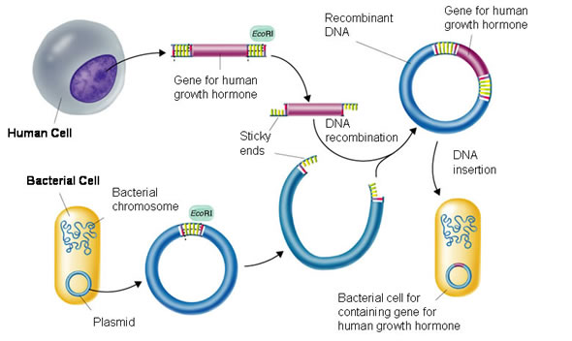

Practice questions

**Describe relationship between hypothalamus and pituitary gland? 6 marks**

* Hypothalamus joined to pituitary gland by the infundibulum
* Anterior lobe of pituitary gland is joined to hypothalamus via network of blood capillaries
* Posterior lobe of the pituitary gland is joined to the hypothalamus via nerve cells extensions (nerve fibres)
* Stimulating and releasing factors control release of hormones from the anterior lobe of the pituitary gland via blood capillaries
* Hormones stored in the posterior lobe are made in hypothalamus
* Their release is stimulated by nerve impulses in the hypothalamus which pass down nerve extensions

Releasing factors are specific for each hormone, they travel through the blood capillaries in the infundibulum to anterior lobe of the pituitary gland